Lab 3

Part I – Reviewing this week’s lectures (record in blog)

Page Layout
- How exactly can cells be spanned across rows and columns in a table? Provide code and examples.
Cells can be spanned using the colspan and rowspan attributes. This can be implemented as an attribute of a cell (i.e. of a <td> or <th> tag). The snippet of code below shows multiple cells colspan & rowspan’s being adjusted.
<!DOCTYPE html>
<html>
<table border="1">

<tr>
<td colspan = "3"> Banner </td>
</tr>

<tr>
<td colspan = "2"> Navigation </td>
<td> About Us</td>
</tr>

<tr>
<td> Main Content </td>
<td> Sidebar </td>
<td rowspan ="3"> Contact </td>
</tr>

<tr>
<td colspan = "2"> Next Row </td>
</tr>
</table>
</html>
The output of this code gives us a table with 3 columns and 4 rows. The Banner cell spans the 3 columns, the Navigation and Next Row cells span the first 2 columns, and the Contact Us column spans the bottom two rows.
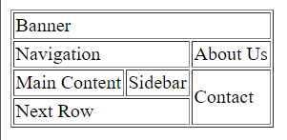
- How did you find coding tables? Outline positive or negative observations, providing examples.
It can be confusing setting up tables at first, as the output is quite abstracted from the HTML that you need to write. However, once you start and have a table of some form coded, it gets easier to tweak and adjust until you have a table exactly the way you want it.
A method that I found greatly helped me visualise what was needed was sketching the table on paper and numbering the cells, so that when you start to write the HTML you have a much clearer direction for what is needed.

Cognition
- Browse some university websites in the USA (observing content, layout, colour, responsiveness …): https://searchenginesmarketer.com/company/resources/university-college-list/

- State four features that these websites have in common. You should state which websites you have analysed:

Caltech - http://caltech.edu/
Berkeley - https://www.berkeley.edu/
MIT - https://web.mit.edu/
Stanford - https://www.stanford.edu/
- They all have the same .edu top level domain.
- They all have the university logo in the top left.
- They all have a search bar on the right side, opposite the logo.
- On the navigation bar, the link to the “About” page is either the leftmost or the rightmost button on all the sites. It’s on the left of the Caltech and Berkeley sites, and on the right on the Stanford and MIT websites. I think this is something I’ll take note of on websites going forward.

- Browse some university websites in Ireland (observing content, layout, colour, responsiveness …): https://www.educationinireland.com/en/Where-can-I-study-/View-all-Universities-Colleges/
- State four features that these websites have in common. You should state which websites you have analysed.
UCC – https://www.ucc.ie/en/international/
NUIG - https://www.nuigalway.ie/international-students/#
DCU - https://www.dcu.ie/international
NUIM - https://www.maynoothuniversity.ie/international
- They all have white backgrounds.
- Like all the US university websites, they all have the logo on the top left.
- All sites were very responsive for me, no problems loading any of them and clicking between pages was smooth with no major hiccups.
- On all the websites, there is the main background colour of white, with 1 major accent colour and 1 minor accent colour. UCC had the nicest colour scheme in my opinion, with the background colour of white, the major accent of yellow and the minor accent colour of a light grey.
- From reading the many articles that I have tweeted on flat design/skeuomorhism/neuomorphism answer the following:
  - What is the meaning of flat design? What website uses flat design?
Flat design is an offshoot of minimalist web design focusing on simple two-dimensional design elements and often bright colours, as a way to “explore the digital medium without trying to reproduce the appearance of the physical world”. It is largely seen as a reactionary design language to skeuomorphism.
Apple’s website (https://www.apple.com/ie/) is a great example of attractive flat design. Featuring simple, clear, flat UI buttons and content. Each page has a very simple, single column style design where all you need to do to take in the information is scroll.
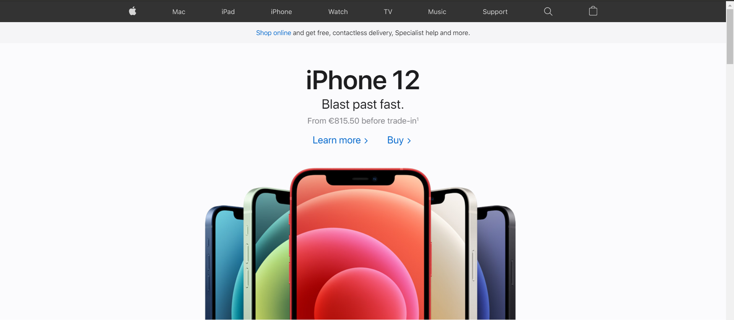
  - What is the meaning of neuomorphism? What website uses neuomorphism?

Part II – Incorporating CSS into Fish Creek
For the external stylesheet, open up a new text file and call it styles.css. Save it in the same directory as your html files. Most of your CSS rules should go in here. You then need to put <link…> in the <head> section of any of the html pages that are using this style sheet. This is External CSS and styles in here will apply to all of your pages.
For styles that apply to only one web page, you should put <style></style> in the head of the html file. The CSS rules go in this tag. This is Embedded CSS.
Some useful tutorials on CSS are as follows:
- W3Schools
- Code Academy
- Khan Academy

Using the Fish Creek website that you created last week, incorporate Cascading Style Sheets (CSS) – embedded and external, as follows:
- All headings should have the same colour, size and font.
- Each page should have a different colour background.
- All hyperlinks should be the same colour before being clicked, when clicked and when hovered over.
- The footer (<footer>) should have the same background colour on both pages, though this colour should differ from the background colour of each page.
- In the unordered list, change the list so that list items use squares rather than circles.
- In the definition list, use CSS (not more tags!) to style <dt> so that it is always bold and underlined.
- Put the navigation links in a <nav> and style this <nav>.

You should check all of your code the HTML Validator - https://validator.w3.org/

